HLM Assignment 2
Part A
- 
MATHijk: Expected math achievement for child i in group j in school k
π0jk: Average math achievement for group j in school k
π1jk: Instantaneous growth rate of math achievement for group j in school k
π2jk: Acceleration rate of math achievement for group j in school k
eijk: Difference between values found and values expected; error term
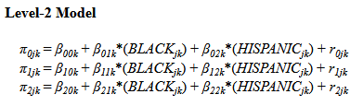
β00k: Mean math achievement for the reference group in school k
β01k: Difference between mean math achievement between the reference group of white students and black students
β02k: Difference between mean math achievement between the reference group of white students and hispanic students
r0jk: Difference between values found and values expected; error term
β10k: Instantaneous growth rate of math achievement for white students in school k
β11k: Difference between instantaneous growth rate between the reference group of white students and black students
β12k: Difference between instantaneous growth rate between the reference group of white students and hispanic students
r1jk: Difference between values found and values expected; error term
β20k: Acceleration rate of math achievement for white students in school k
β21k: Difference between acceleration rate between the reference group of white students and black students
β22k: Difference between acceleration rate between the reference group of white students and hispanic students
r2jk: Difference between values found and values expected; error term
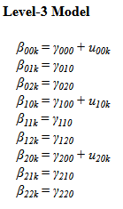
γ000: Mean of school means for the reference group of white students
u00k: Random effect for school at level 3
γ010: Mean difference in math achievement between the reference group of white students and black students
γ020: Mean difference in math achievement between the reference group of white students and hispanic students
γ100: Average increase in math achievement for each one-unit change in year
u10k: Random effect for instantaneous growth rate at level 3
γ110: Difference between instantaneous growth rate between the reference group of white students and black students
γ120: Difference between instantaneous growth rate between the reference group of white students and hispanic students
γ200: Acceleration rate of math achievement
u20k: Random effect for acceleration term at level 3
γ210: Difference between acceleration rate between the reference group of white students and black students
γ220: Difference between acceleration rate between the reference group of white students and hispanic students

- Running the model, we find that the average starting math achievement of white students on the Spring of their first year is -0.26, with black students scoring -0.62 lower than the expected value for white students, and hispanic students scoring -0.39 lower than the expected value for white students.
The instantaneous growth rate for white students’ achievement is 0.84, while for black students it is -0.07, and for hispanic students it is 0.03. The acceleration term for white students is -0.06, while for black students it is 0.02, and for hispanic students it is 0.01.
These findings imply that while all students start with a lower than average achievement in math at the start of their first year, hispanic students score even lower, and black students have the lowest average score. White students have a much steeper instantaneous growth slope than black students, but hispanic students seem to have a steeper curve than the reference group, though it is not statistically significant (p > 0.05). Finally, the curve for white students slows in its growth with time, and while it seems to bend slightly less for black and hispanic students, p-values for both are large, indicating these findings are not statistically significant.
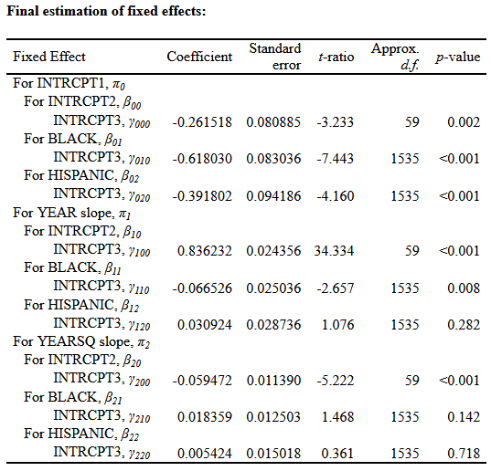
- Examining the graph, it seems that white students have a higher achievement at the start of the timeframe, while starting achievement is very similar for black and hispanic students. The slope for white students slows over time, though their average achievement stays higher than minority students, and the gap between black and hispanic students increases over time, with hispanic students scoring higher and approaching the achievement of white students.
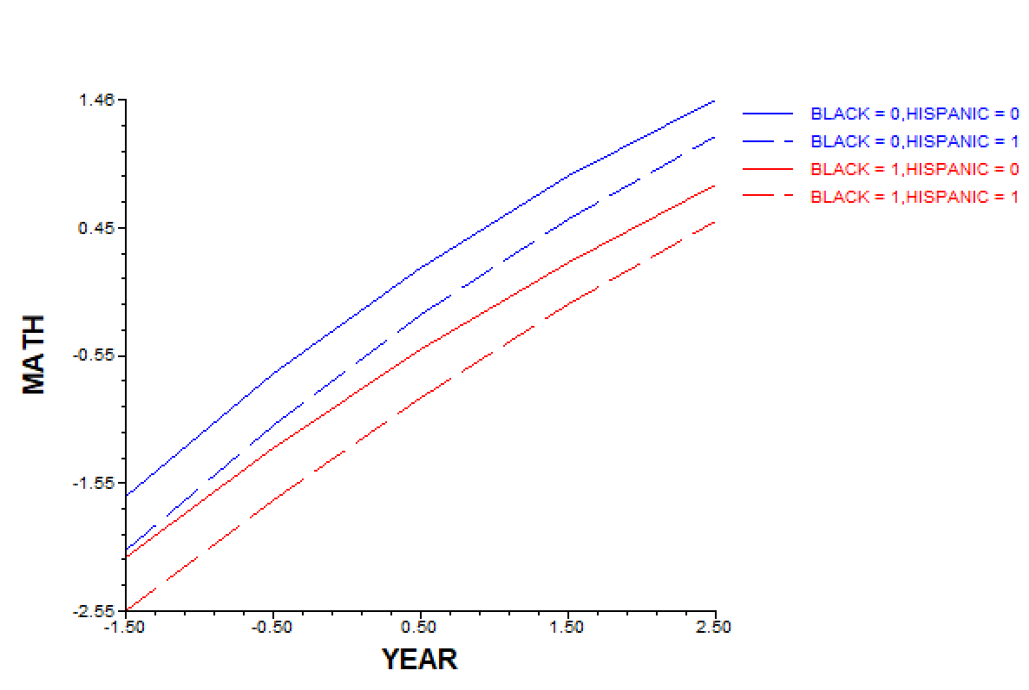
- When only allowing those three terms to vary in the model, we assume that the means can vary for all other terms, but that the slope for other variables does not vary. This means we are not looking closely at individual differences between specific students and their variability.
- Child-level variation for white students:
-0.26 ± 1.96*(0.86) = (-1.95, 1.43)
School-level variation for white students:
-0.26 ± 1.96*(0.35) = (-0.95, 0.43)
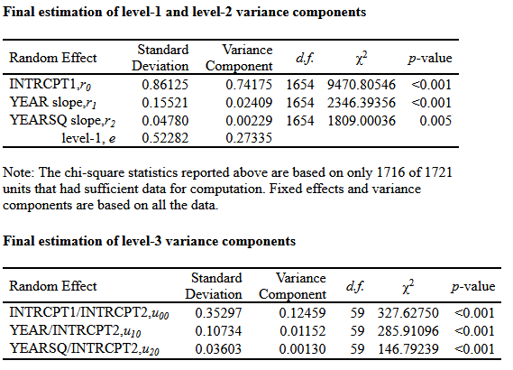
- We have evidence that school poverty predicts children’s growth rates.
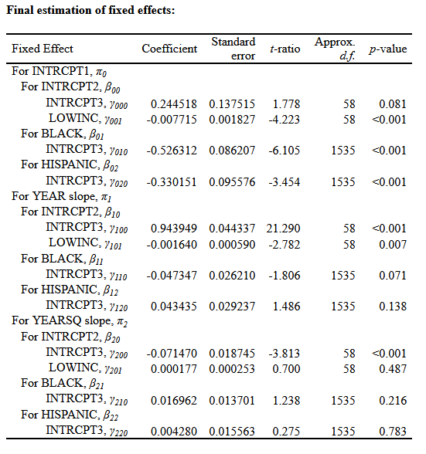
- Comparing this output to the initial model, γ000 becomes positive and is no longer statistically significant. We see that γ001 is negative, indicating low-income students start at a lower average, and their instantaneous growth rate is also lower.
Part B
- The sampling model follows a binomial distribution in which the outcome variable BAGRAD is coded as 1 if the individual obtained a BA degree, and 0 if not, with ϕti representing the specific predicted probability of BA acquisition. This follows a Bernoulli distribution in which the logit link function is log[ϕ_{ti}/(1 - ϕ_{ti})].
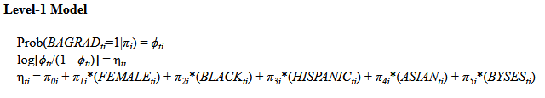
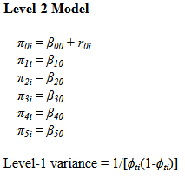
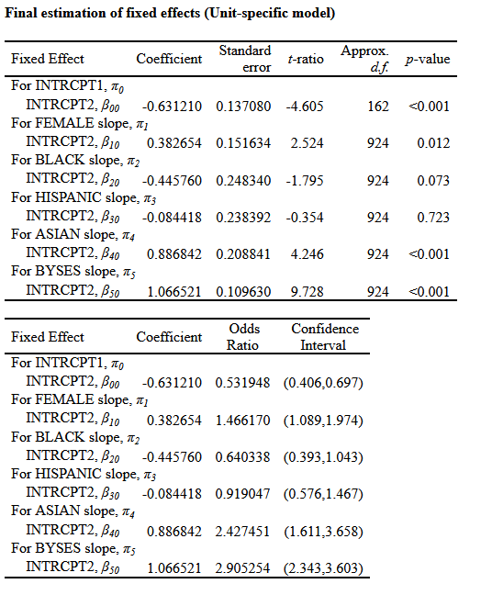
- Predicted probabilities are calculated with $\frac{ⅇ^{η_{ij}}}{1+ⅇ^{η_{ij}}}$
- White male: η_{ti} = -0.63
p = 0.35
- White female: η_{ti} = -0.63 + 0.38 = -0.25
p = 0.44
- Hispanic male: η_{ti} = -0.63 – 0.08 = -0.71
p = 0.33
- Hispanic female: -0.63 + 0.38 – 0.08 = -0.33
p = 0.42
- The change in probability associated with being female is different for hispanic and white students due to the effect of being a hispanic student having a negative effect on the probabilities of achieving a BA degree.
- Compared to the average coefficient of -0.83, Catholic schools seem to lead to a statistically significant higher chance of graduation with a coefficient of 1.19, indicating a sector effect on the education gap.
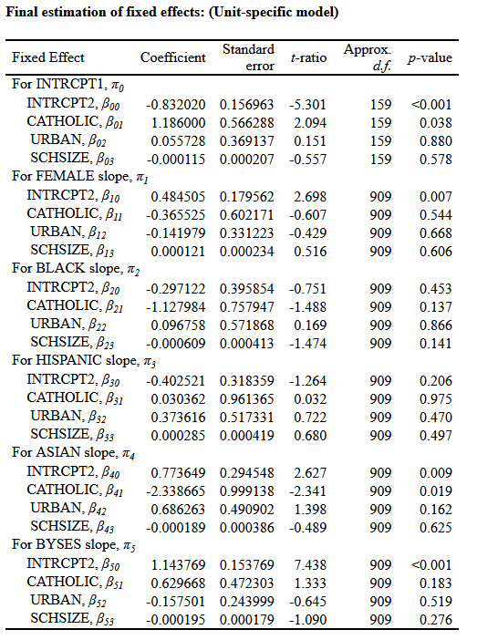
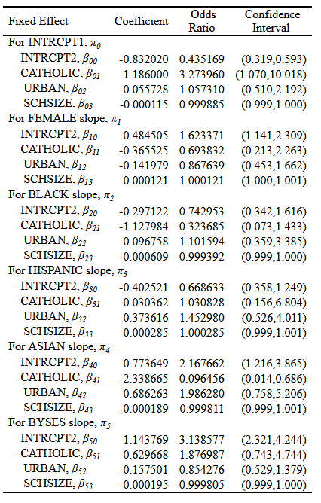
- The models seem to indicate that there are significant differences in the rate of graduation accounting for individual differences and school-level differences. Female students seem to have a higher probability of graduating than their male colleagues, and students who studied in Catholic schools seem to have a higher likelihood of obtaining a BA degree as well.

